TCS3351 Cryptography and Data Security
Tutorial 4
Modern Symmetric Ciphers-I (Feistel Cipher Structure, DES, Mutiple DES)

- Distinguish between the following:

- A block cipher and a stream cipher
- Diffusion and Confusion

Answer:
- Block cipher breaks down plaintext messages into a fixed-size block, commonly 64 or 128-bit, before converting (encrypting) them into ciphertext using a key. The ciphertext block produced is of equal length as its plaintext block.
Stream cipher breaks down plaintext messages into single bits, which then are converted (encrypted) individually (either one bit or one byte) into ciphertext using key bits.
- Diffusion describes the dissipation of the statistical structure of the plaintext into long-range statistics of ciphertext. Its goal is to create a complex statistical relationship between plaintext and ciphertext to protect the secret key. This property is usually done by using permutation operation. DES Expansion. English words statistic in Dictionary.
Confusion seeks to make the relationship between the statistics of the encryption key and ciphertext as complex as possible. This is usually achieved via substitution operation.

- What kind of attack on double DES makes it useless? Explain briefly.

Answer:
Meet-in-the-middle. Based on the Double DES architecture, the encryptions are $M=Enc\left(K_{1},P\right)$ and $C=Enc\left(K_{2},M\right)$; and the decryptions are $M=Dec\left(K_{2},C\right)$ and $P=Dec\left(K_{1},M\right)$.

Notice that the 1st encryption output $M=Enc\left(K_{1},P\right)$ is the same as the 1st decryption output $M=Dec\left(K_{2},C\right)$. Under the known-plaintext attack environment, an attacker may use brute-force attack to exhaustively encrypts $P$ using all the $2^{56}$ possible key $K_{1}$ and decrypts $C$ using all the $2^{56}$ possible key $K_{2}$. The results are then sorted out and tabulated into two lists. If there exists a unique match of $M$ from both the lists, then the attacker has found the corresponding key-pair $\left(K_{1},K_{2}\right)$ of the Double DES. Otherwise, the known-plaintext attack is repeated until the desired unique pair of $\left(K_{1},K_{2}\right)$ is found.

===================== ================
Plaintxt | Enc(key1, plaintxt) | X | Enc(key2, X) | CipherText
============== |  |  | =====
Plaintxt | Enc(key1, plaintxt) | Same X | Dec(key2, CipherTxt) | CipherText
Known |  |  |  | Known | Known plaintext attack
56 bit + 56 bit = 112 bit security (false).
Due to meet in the middle attack.
Try all possible key1 and key2, until U get the same X value
- Key1 and key2 is broken.
Key1 = 2^(56) possible value, Key2 = 2^(56)
On average, U get the result by search half of the possible space. Computation required 2^(56).

- Determine whether the P-box with the following permutation table is a straight P-box, a compression P-box (64 bit to 56 bit) , or an expansion P-box. Give the reason for your answer.*

(i)
4 | 2 | 2 | 5 | 1 | 4 | 3

(ii)
5 | 7 | 9 | 1 | 2 | 8 | 4

(iii)
4 | 2 | 6 | 7 | 1 | 5 | 3

Answer:
- Expansion P-box. 32 bit -> 48 bits. The number of input bits is less than the total number of output bits. Hence, repeated bits are required to expand into longer bits.
- Compression P-box. 64 bit -> 56 bits. The number of input bits is greater than the total number of output bits. Hence, some bits are compressed to reduce into shorter bits.
- Straight P-box. 64 bit <-> 64 bit. IP, IP-1, Permuted Choice 1, 2. The number of input bits equals the total number of output bits. All bits are permuted into random positions of equal length.

- The following table defines the input/output relationship for an S-box of size 3x2. The leftmost bit of the input defines the row; the two rightmost bits of the input define the column. The two output bits are values on the cross-section of the selected row and column. Row and column numbers and inside elements are given in decimal. Input 3 bit, output 2 bit.

 | 0 (00) | 1 (01) | 2 (10) | 3 (11)
0 | 0 | 2 | 1 | 3
1 | 2 | 0 | 3 | 1

Identify the output (in binary) for the input (binary)
- 010
- 001
- 111

Answer:
- 01
- 10
- 01

- Real S-Box

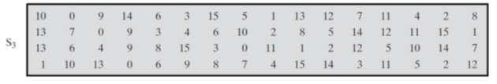
Input : 101010
Output:
Row : outer bit. Bit 1 & 6. : 10 (binary) => 2
Column : middle bit : 0101 : 5
[2,5] => 15 decimal => 1111 (binary)

Output: 14, what is the possible input?
[0,3] => row 0 => , column 3 => 0011
Possible input : 0 0011 0

Another possible input
[1,11]

- With respect to Data Encryption Standard (DES), the steps involved are given below.

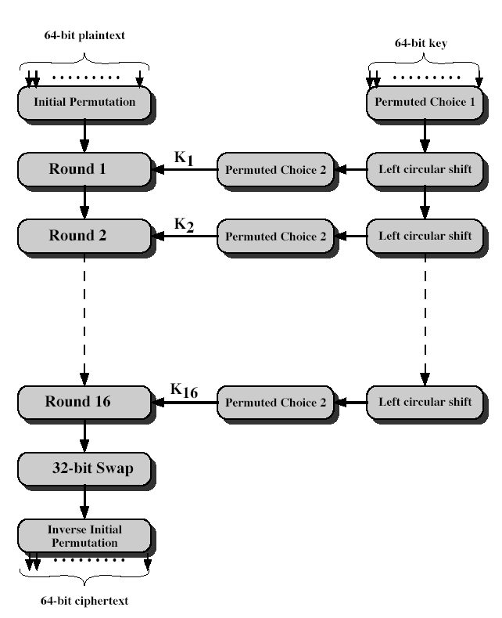

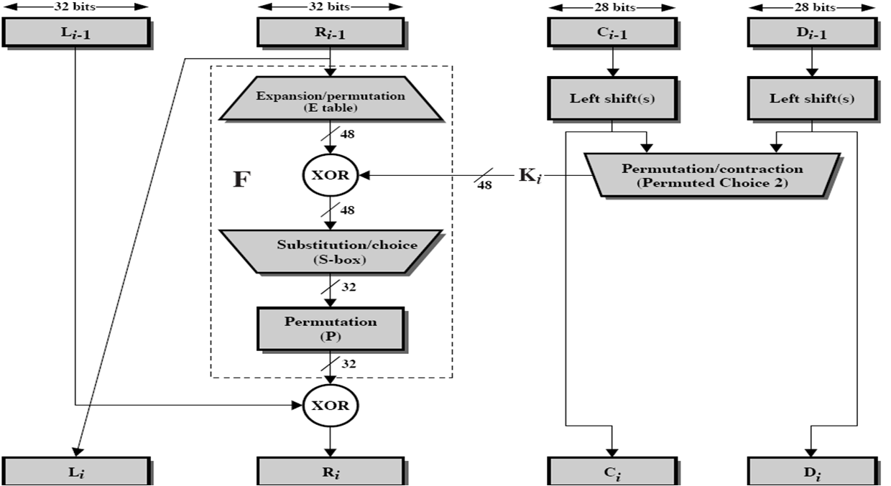
Details of one round in DES are given in the following diagram.

Answer the following questions for the first round of DES. Refer to the above diagrams.
Assume the same bit pattern for the key and the plaintext, namely
1111 1110 1101 1100 1011 1010 1001 1000 0111 0110 0101 0100 0011 0010 0001 0000

- Derive K₁, the first-round sub-key.

64 -> 56 bits
1111 1110 1101 1100 1011 1010 1001 1000
0111 0110 0101 0100 0011 0010 0001 0000

1111 111 1101 110 1011 101 1001 100 0111 011 0101 010 0011 001 0001 000

Blue color = 64 bit raw key. Strike bit 0 is the removed 8th bit from each of the bytes in 64 bit.
Red color = after Permutation 1.
1 | 1 | 1 | 1 | 1 | 1 | 1 | 0 | 1 | 1 | 0 | 1 | 1 | 1 | 0 | 0 | 1 | 0 | 1 | 1 | 1 | 0 | 1 | 0 | 1 | 0 | 0 | 1 | 1 | 0 | 0 | 0
1 | 2 | 3 | 4 | 5 | 6 | 7 | 8 | 9 | 1  0 | 11 | 12 | 13 | 14 | 15 | 16 | 17 | 18 | 19 | 2  0 | 21 | 22 | 23 | 24 | 25 | 26 | 27 | 28 | 29 | 30 | 31 | 32
0 | 0 | 0 | 0 | 1 | 1 | 1 | 1 | 0 | 0 | 1 | 1 | 0 | 0 | 1 | 1 | 0 | 1 | 0 | 1 | 0 | 1 | 0 | 1
0 | 1 | 1 | 1 | 0 | 1 | 1 | 0 | 0 | 1 | 0 | 1 | 0 | 1 | 0 | 0 | 0 | 0 | 1 | 1 | 0 | 0 | 1 | 0 | 0 | 0 | 0 | 1 | 0 | 0 | 0 | 0
33 | 34 | 35 | 36 | 37 | 38 | 39 | 40 | 41 | 42 | 43 | 44 | 45 | 46 | 47 | 48 | 49 | 50 | 51 | 52 | 53 | 54 | 55 | 56 | 57 | 58 | 59 | 60 | 61 | 62 | 63 | 64
 |  |  |  |  |  |  |  |  |  |  |  |  |  |  |  | 1 | 1 | 1 | 1 | 1 | 1 | 1 | 1
Ans: 0000 1111 0011 0011 0101 0101 1111 0101 0101 0011 0011 0000 1111 1111

- Permutation Choice 1:
0000 1111 0011 0011 0101 0101 1111 0101 0101 0011 0011 0000 1111 1111

DES Key Schedule Calculation
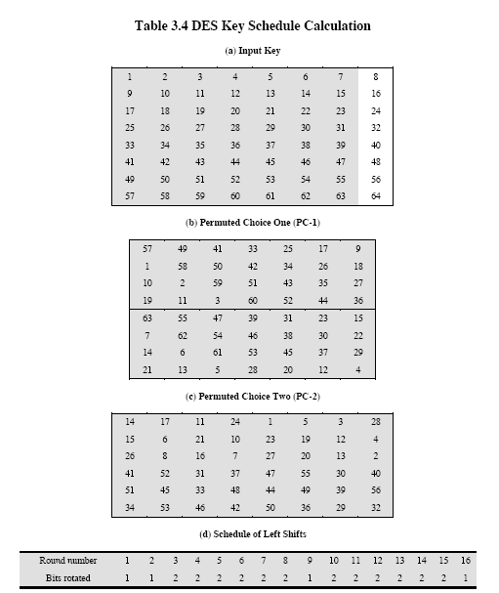

- Derive L₀, R₀.

Initial Permutation Table (IP)
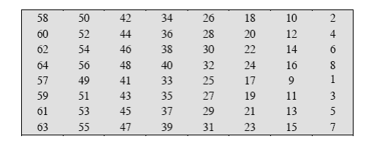

After Permuted Choice 1 . Left | Right
0000 1111 0011 0011 0101 0101 1111 | 0101 0101 0011 0011 0000 1111 1111
Left shift by 1 bit: Round 1
0001 1110 0110 0110 1010 1011 1110 | 1010 1010 0110 0110 0001 1111 1110

Left: Permuted Choice -2 Right (24th bit onwards)
0 | 0 | 0 | 1 | 1 | 1 | 1 | 0 | 0 | 1 | 1 | 0 | 0 | 1 | 1 | 0 | 1 | 0 | 1 | 0 | 1 | 0 | 1 | 1 | 1 | 1 | 1 | 0
1 | 2 | 3 | 4 | 5 | 6 | 7 | 8 | 9 | 1  0 | 11 | 12 | 13 | 14 | 15 | 16 | 17 | 18 | 19 | 2  0 | 21 | 22 | 23 | 24 | 25 | 26 | 27 | 28
1 | 1 | 1 | 1 | 0 | 1 | 0 | 0 | 1 | 1 | 1 | 1 | 1 | 1 | 0 | 1

Right: Permuted Choice -2
1 | 0 | 1 | 0 | 1 | 0 | 1 | 0 | 0 | 1 | 1 | 0 | 0 | 1 | 1 | 0 | 0 | 0 | 0 | 1 | 1 | 1 | 1 | 1 | 1 | 1 | 1 | 0
29 | 30 | 31 | 32 | 33 | 34 | 35 | 36 | 37 | 38 | 39 | 40 | 41 | 42 | 43 | 44 | 45 | 46 | 47 | 48 | 49 | 50 | 51 | 52 | 53 | 54 | 55 | 56
 |  |  |  |  |  |  |  |  |  |  |  | 0 | 1 | 0 | 1 | 1 | 0 | 1 | 0
Ignore bit : 9, 18, 22, 25, 35, 38, 43, 54

Permutation Choice 2:
After Permuted Choice 2
$$1111 0100 1111 1101 1001 1000$$ | 0110 0100 1011 0110 0101 1010

$1111 0100 1111 1101 1001 1000$ 0110 0100 1011 0110 0101 1010

Hence, the first- round subkey $K_{1}:$

$$1111 0100 1111 1101 1001 1000 0110 0100 1011 0110 0101 1010$$

>>>>>>>>>>
Now is the DATA part, where U do the encryption of data.

- Expand R₀ to get E [R₀].
Data: 1111 1110 1101 1100 1011 1010 1001 1000 0111 0110 0101 0100 0011 0010 0001 0000

Do IP (Initial Permutation 1st).
1 | 1 | 1 | 1 | 1 | 1 | 1 | 0 | 1 | 1 | 0 | 1 | 1 | 1 | 0 | 0 | 1 | 0 | 1 | 1 | 1 | 0 | 1 | 0 | 1 | 0 | 0 | 1 | 1 | 0 | 0 | 0
1 | 2 | 3 | 4 | 5 | 6 | 7 | 8 | 9 | 1  0 | 11 | 12 | 13 | 14 | 15 | 16 | 17 | 18 | 19 | 2  0 | 21 | 22 | 23 | 24 | 25 | 26 | 27 | 28 | 29 | 30 | 31 | 32
0 | 0 | 1 | 1 | 0 | 0 | 1 | 1 | 1 | 1 | 1 | 1 | 1 | 1 | 1 | 1
0 | 1 | 1 | 1 | 0 | 1 | 1 | 0 | 0 | 1 | 0 | 1 | 0 | 1 | 0 | 0 | 0 | 0 | 1 | 1 | 0 | 0 | 1 | 0 | 0 | 0 | 0 | 1 | 0 | 0 | 0 | 0
33 | 34 | 35 | 36 | 37 | 38 | 39 | 40 | 41 | 42 | 43 | 44 | 45 | 46 | 47 | 48 | 49 | 50 | 51 | 52 | 53 | 54 | 55 | 56 | 57 | 58 | 59 | 60 | 61 | 62 | 63 | 64
 |  |  |  |  |  |  |  |  |  |  |  |  |  |  |  |  |  |  |  |  |  |  |  | 0 | 1 | 0 | 1 | 0 | 1 | 0 | 1

- $L_{0}:0011 0011 1111 1111 0011 0011 0000 0000$
$R_{0}: 0000 1111 0101 0101 0000 1111 0101 0101$

Expansion Permutation (E) Table
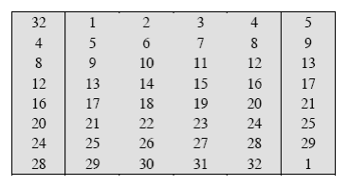

Expansion is only for $R_{0}:$
0 | 0 | 0 | 0 | 1 | 1 | 1 | 1 | 0 | 1 | 0 | 1 | 0 | 1 | 0 | 1 | 0 | 0 | 0 | 0 | 1 | 1 | 1 | 1 | 0 | 1 | 0 | 1 | 0 | 1 | 0 | 1
1 | 2 | 3 | 4 | 5 | 6 | 7 | 8 | 9 | 1  0 | 11 | 12 | 13 | 14 | 15 | 16 | 17 | 18 | 19 | 2  0 | 21 | 22 | 23 | 24 | 25 | 26 | 27 | 28 | 29 | 30 | 31 | 32
1 | 0 | 0 | 0 | 0 | 1 | 0 | 1 | 1 | 1 | 1 | 0 | 1 | 0 | 1 | 0 | 1 | 0 | 1 | 0 | 1 | 0 | 1 | 0 | 1 | 0 | 0 | 0 | 0 | 1
33 | 34 | 35 | 36 | 37 | 38 | 39 | 40 | 41 | 42 | 43 | 44 | 45 | 46 | 47 | 48

- $E\left[R_{0}\right]:100001 011110 101010 101010 100001 011110 101010 101010$

- Calculate A = E[R₀] ⊕ K₁.
$$E\left[R_{0}\right]:100001 011110 101010 101010 100001 011110 101010 101010$$

$$100001 011110 101010 101010 100001 011110 101010 101010$$
$$⊕111101 001111 110110 011000 011001 001011 011001 011010$$
$$A: 011100 010001 011100 110010 111000 010101 110011 110000$$

S1 | S2 | S3 | S4 | S5 | S6 | S7 | S8
011100 | 010001 | 011100 | 110010 | 111000 | 010101 | 110011 | 110000
[0,14] | [1,8] | [0,14] | [2,9] | [2,12] | [1,10] | [3,9] | [2,8]
0 | 12 | 2 | 1 | 6 | 13 | 5 | 0
0000 | 1100 | 0010 | 0001 | 0110 | 1101 | 0101 | 0000
Result: 0000 1100 0010 0001 0110 1101 0101 0000

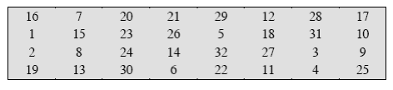
Permutation.

0 | 0 | 0 | 0 | 1 | 1 | 0 | 0 | 0 | 0 | 1 | 0 | 0 | 0 | 0 | 1 | 0 | 1 | 1 | 0 | 1 | 1 | 0 | 1 | 0 | 1 | 0 | 1 | 0 | 0 | 0 | 0
1 | 2 | 3 | 4 | 5 | 6 | 7 | 8 | 9 | 1  0 | 11 | 12 | 13 | 14 | 15 | 16 | 17 | 18 | 19 | 2  0 | 21 | 22 | 23 | 24 | 25 | 26 | 27 | 28 | 29 | 30 | 31 | 32
1 | 0 | 0 | 1 | 0 | 0 | 1 | 0 | 0 | 0 | 0 | 1 | 1 | 1 | 0 | 0 | 0 | 0 | 1 | 0 | 0 | 0 | 0 | 0 | 1 | 0 | 0 | 1 | 1 | 1 | 0 | 0

$$P\left(B\right):1001 0010 0001 1100 0010 0000 1001 1100$$

XOR with Left Side.

- $R_{1}=P\left(B\right)⊕L_{0}:$

$$1001 0010 0001 1100 0010 0000 1001 1100$$
$$⊕ 0011 0011 1111 1111 0011 0011 0000 0000$$
$$R_{1}:1010 0001 1110 0011 0000 0011 1001 1100$$

- Ciphertext after first round:
$$0000 1111 0101 0101 0000 1111 0101 0101 1010 0001 1110 0011 0000 0011 1001 1100$$

>>>>> end >>>>>>>>>>>>>>

- Group the 48-bit result of (iv) into sets of 6 bits and evaluate the corresponding S-box substitutions.

(vi) Concatenate the results of (v) to get a 32-bit result, B.
(vii) Apply the permutation to get P(B).

Permutation Function (P)



(viii) Calculate R₁ = P(B) ⊕ L₀.
(ix) Write down the intermediate ciphertext after the first round.

Answer:
- Permutation Choice 1:
0000 1111 0011 0011 0101 0101 1111 0101 0101 0011 0011 0000 1111 1111

Left shift by 1 bit:
0001 1110 0110 0110 1010 1011 1110 1010 1010 0110 0110 0001 1111 1110

Permutation Choice 2:
$1111 0100 1111 1101 1001 1000$ 0110 0100 1011 0110 0101 1010

Hence, the first- round subkey $K_{1}:$

$$1111 0100 1111 1101 1001 1000 0110 0100 1011 0110 0101 1010$$

- $L_{0}:0011 0011 1111 1111 0011 0011 0000 0000$
$R_{0}: 0000 1111 0101 0101 0000 1111 0101 0101$

- $E\left[R_{0}\right]:100001 011110 101010 101010 100001 011110 101010 101010$

- $A=E\left[R_{0}\right]⊕K_{1}:$

$$100001 011110 101010 101010 100001 011110 101010 101010$$
$$⊕111101 001111 110110 011000 011001 001011 011001 011010$$
$$A: 011100 010001 011100 110010 111000 010101 110011 110000$$

- $0000 1100 0010 0001 0110 1101 0101 0000$

- $B: 0000 1100 0010 0001 0110 1101 0101 0000$

- $P\left(B\right):1001 0010 0001 1100 0010 0000 1001 1100$

- $R_{1}=P\left(B\right)⊕L_{0}:$

$$1001 0010 0001 1100 0010 0000 1001 1100$$
$$⊕ 0011 0011 1111 1111 0011 0011 0000 0000$$
$$R_{1}:1010 0001 1110 0011 0000 0011 1001 1100$$

- Ciphertext after first round:
$$0000 1111 0101 0101 0000 1111 0101 0101 1010 0001 1110 0011 0000 0011 1001 1100$$

References:
1. Behrouz A. Forouzan, Debdeep Mukhopadhyay, "Cryptography and Network Security", Third Edition, McGraw-Hill, 2015.

2. William Stallings, “Cryptography and Network Security – Principles and Practice”,
Seventh Edition, Prentice Hall, 2017.

